OUM

DS.140 Design Specification

Cigna Corporation

BI-FA-0002 Fixed Asset Reporting

Author: Nitesh Kumar

Creation Date: October 1, 2015

Last Updated: October 13, 2016

Document Ref: BI-FA-0002_CIGNA FD Fixed Asset Reporting

Version: 1.45

1. **Title, Subject, Last Updated Date, Reference Number**, **and** **Version** are marked by a Word Bookmark so that they can be easily reproduced in the header and footer of documents. When you change any of these values, be careful not to accidentally delete the bookmark. **You can make bookmarks visible by selecting the Office Button>Word Options>Advanced> and checking the Show bookmarks option in the Show document content region.**

**Approvals:**

|  |  |
| --- | --- |
| <Approver 1> | Vinay Pachika |
| <Approver 2> | Viswam Nair |

1. To add additional approval lines, press [Tab] from the last cell in the table above.



1. You can delete any elements of this cover page that you do not need for your document.

# Document Control

## Change Record

5

| **Date** | **Author** | **Version** | **Change Reference** |
| --- | --- | --- | --- |
| 1-October-2015 | Medishetty Nitesh Kumar | 1.0 | No Previous Document |
| 12-April-2016 | Krishna Prasad Pangath | 1.1 | Updated in Sections 4,6.4.2,6.5,7.2,7.5 related to adding Asset Classification prompt to fix the issue with duplicate records Issue for Expense Center code developed as part of Release 1B |
| 21-Apr-2016 | P Sony Keerthi Reddy | 1.2 | Release 1B-  Added new columns: Total Life Months, Asset Transaction Type Name and Asset Transaction Sub Type Code  Added new prompt: Input Ledger Company  Updated these changes in below section:  3.1 Data Lineage/Mapping  5.2.1 Source System - Data Objects  5.3.3 Target System - Data Objects  6.3.4 Database Objects - Tables/Views  6.4.2 Business Rules  6.5 Presentation Layer  7.2 User Prompt  7.4 Data Fields  7..5 Report Filters |
| 12-May-2016 | Krishna Prasad Pangath | 1.3 | Release 1B: Updated changes for Cost (remapped to Current Cost), Removed Asset Transaction Type Name and Asset Transaction Sub Type code. Added columns for Cost Pool and Depreciation Method which were earlier left unmapped and hard coded to NULL. The changes were done to sections 5.2.1,5.3.3,6.3.4,6.5,7.4,9.1 |
| 11-Aug-2016 | P.S.Keerthi Reddy | 1.4 | Rel 2 Changes and Release2 CRP1 ER#1042 and 1135  Changes are done in the below section:  3 Technical Overview  3.1 Data Lineage Mapping  4 Custom Component List  5.2.1 Data Objects  5.3.3 Data Objects  6.2 Physical Diagram  6.3.4 Tables/Views  6.4.1 Logical Diagram  6.4.2 Business Rules  6.5 Presentation Layer  7.2 User Prompts  7.5 Report Filters |
| 06-Oct-2016 | Manudeep Gudigunta | 1.5 | Rel 2 CRP ER:1042,1137  Changes are done in below section:  7.2 User Prompts  7.4 Data Fields  7.5 Report Filters |

## Reviewers

| **Name** | **Position** |
| --- | --- |
| Siva Balakrishnan | TCS |
| Siddhartha Sarkar | TCS |

## Distribution

| **Name** | **Position** |
| --- | --- |
| Vinay Pachika | Cigna |
| Viswam Nair | Cigna |

Contents

1 Document Control 2

1.1 Change Record 2

1.2 Reviewers 3

1.3 Distribution 3

2 Business Overview 6

2.1 Assumptions 6

2.2 Risks & Issues 7

2.3 Referential Documents 7

2.4 Definitions and Acronyms 7

2.5 Block Diagram 8

3 Technical Overview 9

3.1 Data Lineage/Mapping 13

4 Custom Components list 14

5 ELT Overview 15

5.1 Data Flow Model 15

5.2 Source System 15

5.3 Target System 17

5.4 Indexes 18

5.5 Load plans 18

6 RPD Design 19

6.1 Physical Layer 19

6.2 Physical diagram 20

6.3 Database Objects 21

6.4 BMM Layer 23

6.5 Presentation Layer 26

7 Report Design 28

7.1 Report Details 28

7.2 User Prompts 28

7.3 Header 29

7.4 Data Fields 29

7.5 Report Filters 32

7.6 Interfaces- External 33

7.7 Security 33

8 Performance 34

8.1 Performance Considerations/Requirements 34

8.2 Stress Test 34

8.3 Loading Timing/Benchmarking 34

9 Open and Closed Issues 35

9.1 Open Issues 35

9.2 Closed Issues 35

1. To update the table of contents, put the cursor anywhere in the table and press [F9]. To change the number of levels displayed, select the menu option Insert‑>Index and Tables, make sure the Table of Contents tab is active, and change the Number of Levels to a new value.

# Business Overview

As part of the Building Financial Foundations project, Oracle Enterprise Business Suite (EBS) R12 was implemented / upgraded in an effort to modernize the overall accounting and financial reporting process. Reporting for the General Ledger (GL), Accounts Payable (AP), Fixed Assets (FA) and Accounts Receivable (AR) were developed in Discoverer.

To build upon the current reporting, the Expense Redesign projects plans to implement Business Intelligence (BI) to:

* Integrated systems and reporting tools to automate business processes and better insight into data resulting in time and cost savings
* Self-Service Business Intelligence to aid timely and intelligent business decisions by providing trustworthy and relevant and timely access to data
* Build a solid foundation for future reporting needs, including management reporting and analytics. Replace older reporting tools with modern and more effective integrated reporting technologies
* Provide a platform for analytical and operational reporting
* Adhoc, reporting with drilldown and dashboard capabilities
* Extend the current operational reporting capabilities
* Enhance analytical, real time, metadata reporting capabilities

Business Intelligence reporting will be standardized on the Oracle Business Intelligence Enterprise Edition (OBIEE) platform. Oracle Business Intelligence Application (OBIA) will be implemented to support GAAP, STAT, MLR reporting, extend analysis capabilities, and provide operating expense reporting to various areas in the Finance community.

Fixed Asset Reporting is used for FA purpose reporting purpose only. Earlier CES-II tool was used by Cigna to full fill these FA reporting needs and users had the ability to runs this report in CES-II to get the Fixed Assets details by accounting period & now it is available in OBIEE

## Assumptions

|  |  |
| --- | --- |
| **Number** | **Assumption** |
| 1 | Report must show all accounted transactions for both open and closed period. Unaccounted transactions are not part of this report |
| 2 | Data should not be truncated |
| 3 | Date format : DD-MON-YYYY |
| 4 | Report performance should be as per Cigna guidelines |
| 5 | Apply the Cigna report development guidelines. No hard coding etc. |
| 6 | Default font size: 10 default font type: Arial |
| 7 | All the active currencies with the currency exchange rates are available in EBS |
| 8 | Oracle R12 EBS Fixed Assets is the source of BI reports; therefore BI is not responsible for any data issue. |
| 9 | BI will leverage EBS ledger security defined in respective roles & responsibilities. BI will not have any custom security and/or roles to be defined. |
| 10 | Amount format should be with thousand separator with two decimals. Example 1,014,392.91 |

## Risks & Issues

|  |  |  |  |
| --- | --- | --- | --- |
| **ID** | **Risk/Issue** | **Probability**  **(H/M/L)** | **Mitigation** |
| R&I-1 | Any change in source table structure | H | Data acquisition ETLs have to be modified accordingly. |
| R&I-2 | Incorporation of more than one Summary table and frequent changes in column structures | H | Re-work needs to be done with change in delivery timeline. |

## Referential Documents

The following documents serve as references for the content within this technical design document.

|  |  |
| --- | --- |
| **Name** | **Locations/Attachments** |
| BI-FA-0002_ Fixed Asset Reporting | <https://centralhub.cigna.com/project/epms13058/Expense%20Reporting/Release%201B/TCS-Development/06-DS-140%20Technical%20Design%20TD/TD_DS-140_BI-FA-0002_Fixed%20Asset%20Reporting> |

## Definitions and Acronyms

|  |  |
| --- | --- |
| **Key Word** | **Meaning** |
| OBIEE | Oracle Business Intelligence Enterprise Edition |
| OOB | Out Of The Box |
| RPD | Repository File |
| ETL | Extract, Transform and Load |
| BI | Business Intelligence |

## Block Diagram

**Data Warehouse**

**OOB Dimensions**

**& Fact**

**Fixed Asset Reporting**

**Transactional Source Systems**

**R12 EBS Fixed Assets**

# Technical Overview

The Tax Fixed Asset Reporting involves pulling the data from the OOB EBS Fixed Assets tables, and also leveraging the OOB dimensions for displaying data.

**Technical Approach**

This requirement involves using existing OOB subject area to create a Cigna Fixed Asset dashboard.

As part of the above requirement a join has been applied in the RPD between balancing segment and customized materialized view for segment1 ,prime and customized materialized view for segment3 , expense center and customized materialized view for segment5.

For e.g.: join applied between balancing segment 1 and customized materialized view in the below screen shot

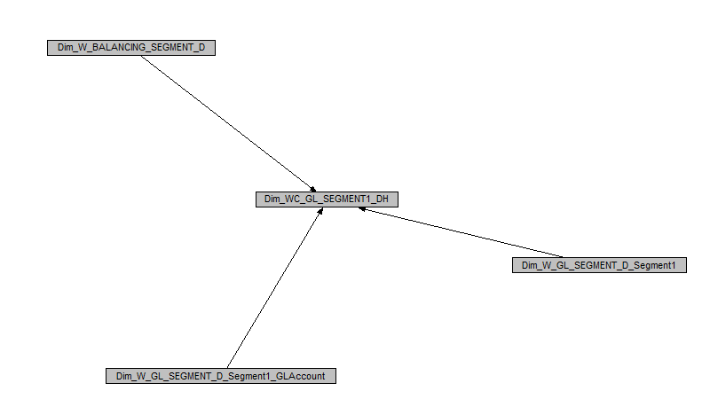

Join applied between natual account and customized materialized view

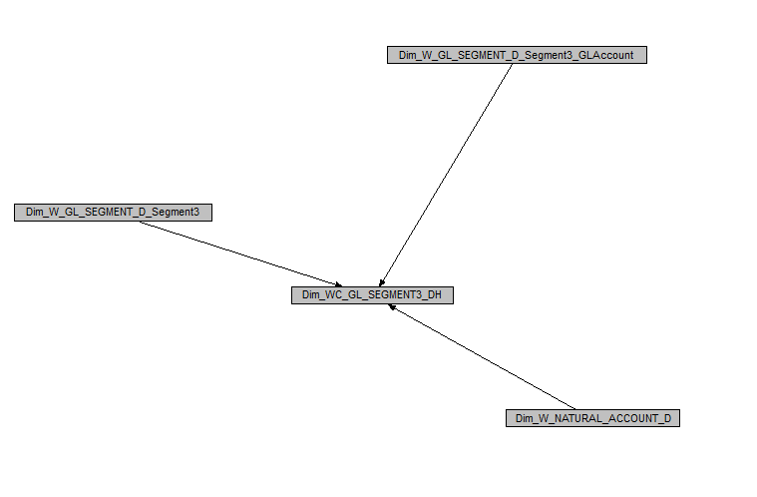

Join applied between costcenter and customized materialized view

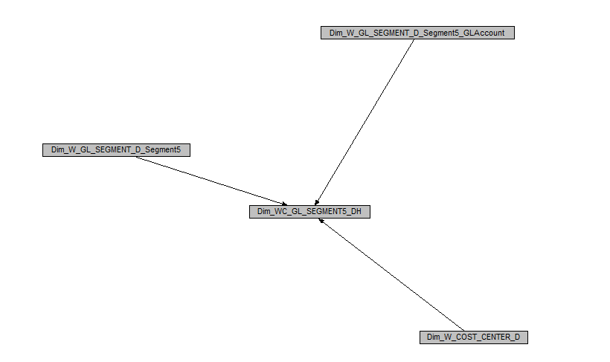

1. The Physical layer contains the objects (Tables, views, mv and Connection pool)) mentioned below.

|  |  |  |
| --- | --- | --- |
| **Object** | **Connection Pool** | **Type** |
| W_MCAL_DAY_D | Oracle Data Warehouse Connection Pool | OOB |
| W_MCAL_PERIOD_D | Oracle Data Warehouse Connection Pool | OOB |
| W_FIXED_ASSET_D | Oracle Data Warehouse Connection Pool | OOB |
| W_LEDGER_D | Oracle Data Warehouse Connection Pool | OOB |
| W_COST_CENTER_D | Oracle Data Warehouse Connection Pool | OOB |
| W_GL_SEGMENT_D_TL | Oracle Data Warehouse Connection Pool | OOB |
| W_ASSET_BOOK_D | Oracle Data Warehouse Connection Pool | OOB |
| W_ASSET_CATEGORY_D | Oracle Data Warehouse Connection Pool | OOB |
| W_ASSET_LOCATION_D | Oracle Data Warehouse Connection Pool | OOB |
| W_FA_BALANCE_F | Oracle Data Warehouse Connection Pool | OOB |
| W_FA_XACT_GRPACCT_FSCLPRD_A | Oracle Data Warehouse Connection Pool | OOB |
| W_PARTY_D | Oracle Data Warehouse Connection Pool | OOB |

1. Aliases for the imported objects in the physical layer are created as per Oracle naming standards.

|  |  |  |
| --- | --- | --- |
| **Alias name** | **Source Table** | **Connection Pool** |
| Dim_W_MCAL_DAY_D_Fiscal_Day | W_MCAL_DAY_D | Cigna Custom Real Time Connection pool |
| Dim_W_MCAL_PERIOD_D_Fiscal_Period | W_MCAL_PERIOD_D | Cigna Custom Real Time Connection pool |
| Dim_W_FIXED_ASSET_D | W_FIXED_ASSET_D | Cigna Custom Real Time Connection pool |
| Dim_ W_FIXED_ASSET_D _Ledger | W_FIXED_ASSET_D | Cigna Custom Real Time Connection pool |
| Dim_W_COST_CENTER_D | W_COST_CENTER_D | Cigna Custom Real Time Connection pool |
| Dim_W_BALANCING_SEGMENT_D | W_BALANCING_SEGMENT_D | Cigna Custom Real Time Connection pool |
| W_GL_SEGMENT_D_TL | SEGMENT_VAL_NAME | Cigna Custom Real Time Connection pool |
| W_GL_SEGMENT_D_TL | Segment_Name | Oracle Data Warehouse Connection Pool |
| Dim_W_NATURAL_ACCOUNT_D | W_NATURAL_ACCOUNT_D | Cigna Custom Real Time Connection pool |
| Dim_W_ASSET_BOOK_D | DATASOURCE_NUM_ID | Oracle Data Warehouse Connection Pool |
| Dim_W_ASSET_BOOK_D | W_ASSET_BOOK_D | Oracle Data Warehouse Connection Pool |
| Dim_W_ASSET_CATEGORY_D | W_ASSET_CATEGORY_D | Oracle Data Warehouse Connection Pool |
| Dim_W_ASSET_LOCATION_D | W_ASSET_LOCATION_D | Oracle Data Warehouse Connection Pool |
| Fact_W_FA_BALANCE_F | W_FA_BALANCE_F | Oracle Data Warehouse Connection Pool |
| Fact_Agg_W_FA_XACT_GRPACCT_FSCLPRD_A | W_FA_XACT_GRPACCT_FSCLPRD_A | Oracle Data Warehouse Connection Pool |
| Dim_W_PARTY_D_Supplier | W_PARTY_D | Oracle Data Warehouse Connection Pool |
| Dim_W_PARTY_ORG_D_Supplier | W_PARTY_D | Oracle Data Warehouse Connection Pool |

1. The physical join conditions among the objects in the Physical layer are mentioned in the below table.

|  |  |  |
| --- | --- | --- |
| **Dimension** | **Fact** | **Physical Join** |
| Dim_W_ASSET_CATEGORY_D | Fact_W_FA_BALANCE_F | "Oracle Data Warehouse"."Catalog"."dbo"."Dim_W_ASSET_CATEGORY_D"."ROW_WID" = "Oracle Data Warehouse"."Catalog"."dbo"."Fact_W_FA_BALANCE_F"."ASSET_CATEGORY_WID" |
| Dim_W_ASSET_BOOK_D | Fact_W_FA_BALANCE_F | "Oracle Data Warehouse"."Catalog"."dbo"."Dim_W_ASSET_BOOK_D"."ROW_WID" = "Oracle Data Warehouse"."Catalog"."dbo"."Fact_W_FA_BALANCE_F"."ASSET_BOOK_WID" |
| Dim_W_BALANCING_SEGMENT_D | Fact_W_FA_BALANCE_F | "Oracle Data Warehouse"."Catalog"."dbo"."Dim_W_BALANCING_SEGMENT_D"."ROW_WID" = "Oracle Data Warehouse"."Catalog"."dbo"."Fact_W_FA_BALANCE_F"."BALANCING_SEGMENT_WID" |
| Dim_W_COST_CENTER_D | Fact_W_FA_BALANCE_F | "Oracle Data Warehouse"."Catalog"."dbo"."Dim_W_COST_CENTER_D"."ROW_WID" = "Oracle Data Warehouse"."Catalog"."dbo"."Fact_W_FA_BALANCE_F"."COST_CENTER_WID" |
| Dim_W_MCAL_PERIOD_D_Fiscal_Period | Fact_W_FA_BALANCE_F | "Oracle Data Warehouse"."Catalog"."dbo"."Dim_W_MCAL_PERIOD_D_Fiscal_Period"."MCAL_PERIOD_END_DT_WID" = "Oracle Data Warehouse"."Catalog"."dbo"."Fact_W_FA_BALANCE_F"."BALANCE_DT_WID" AND "Oracle Data Warehouse"."Catalog"."dbo"."Dim_W_MCAL_PERIOD_D_Fiscal_Period"."MCAL_CAL_WID" = "Oracle Data Warehouse"."Catalog"."dbo"."Fact_W_FA_BALANCE_F"."MCAL_CAL_WID" AND "Oracle Data Warehouse"."Catalog"."dbo"."Dim_W_MCAL_PERIOD_D_Fiscal_Period"."ADJUSTMENT_PERIOD_FLG" = 'N' |
| Dim_W_ASSET_LOCATION_D | Fact_W_FA_BALANCE_F | "Oracle Data Warehouse"."Catalog"."dbo"."Dim_W_ASSET_LOCATION_D"."ROW_WID" = "Oracle Data Warehouse"."Catalog"."dbo"."Fact_W_FA_BALANCE_F"."ASSET_LOCATION_WID" |
| Dim_W_NATURAL_ACCOUNT_D | Fact_W_FA_BALANCE_F | "Oracle Data Warehouse"."Catalog"."dbo"."Dim_W_NATURAL_ACCOUNT_D"."ROW_WID" = "Oracle Data Warehouse"."Catalog"."dbo"."Fact_W_FA_BALANCE_F"."NATURAL_ACCOUNT_WID" |
| Dim_W_FIXED_ASSET_D | Fact_W_FA_BALANCE_F | "Oracle Data Warehouse"."Catalog"."dbo"."Dim_W_FIXED_ASSET_D"."ROW_WID" = "Oracle Data Warehouse"."Catalog"."dbo"."Fact_W_FA_BALANCE_F"."ASSET_WID" |
| Dim_W_PARTY_D_Supplier | Dim_W_FIXED_ASSET_D | "Oracle Data Warehouse"."Catalog"."dbo"."Dim_W_PARTY_D_Supplier"."ROW_WID" = "Oracle Data Warehouse"."Catalog"."dbo"."Dim_W_FIXED_ASSET_D"."X_SUPPLIER_WID" |

## Data Lineage/Mapping



# Custom Components list

|  |  |  |  |  |  |  |  |
| --- | --- | --- | --- | --- | --- | --- | --- |
| **S.No** | **Area** | **Type** | **New /Change?** | **Name** | **Description** | **Purpose** | **Schema** |
| 1 | ANALYTICS | ANALYSIS NAME | New | Cigna Fixed Asset Reporting | N/A | N/A | N/A |
| 2 | ANALYTICS | DASHBOARD Name | New | Cigna Fixed Asset | N/A | N/A | N/A |
| 3 | ANALYTICS | DASHBOARD Prompt | New | Cigna Fixed Asset Prompt | N/A | N/A | N/A |
| 4 | RPD | Presentation Column | New | Account Classification | N/A | N/A | N/A |
| 5 | RPD | Logical Column | New | Account Classification | N/A | N/A | N/A |
| 6 | RPD | Logical Column | New | Dim - Fixed Asset Purchase Order Number | N/A | N/A | N/A |
| 7 | RPD | Presentation Column | New | PO Number | N/A | N/A | N/A |
| 8 | RPD | Presentation Column | New | Supplier Name | N/A | N/A | N/A |
| 9 | RPD | Presentation Column | New | Supplier Number | N/A | N/A | N/A |

# ELT Overview

NA

## Data Flow Model

.

There were no modifications/changes done for data flow model at the ELT side for this component.

## Source System

* + 1. **Data objects**

|  |  |  |
| --- | --- | --- |
| **Source(Table/View)** | **Column** | **Description** |
| GL_PERIODS | PERIOD_NAME | N/A |
| GL_PERIODS | PERIOD_NAME | N/A |
| FA_ADDITIONS_B | ASSET_NUMBER | N/A |
| FA_BOOKS | DATE_PLACED_IN_SERVICE | N/A |
| FA_BOOKS | DEPRN_START_DATE | N/A |
| FA_ADDITIONS_B | SERIAL_NUMBER | N/A |
| FA_ADDITIONS_B | TAG_NUMBER | N/A |
| W_FIXED_ASSET_D | TOTAL_LIFE_IN_MONTHS | N/A |
| FA_BOOKS | ASSET_DESCR | N/A |
| FA_LEASES | LEASE_NUMBER | N/A |
| GL_LEDGERS | NAME | N/A |
| GL_CODE_COMBINATIONS | SEGMENT5 | N/A |
| GL_CODE_COMBINATIONS | SEGMENT5 | N/A |
| GL_CODE_COMBINATIONS | SEGMENT5 | N/A |
| GL_CODE_COMBINATIONS | SEGMENT1 | N/A |
| GL_CODE_COMBINATIONS | SEGMENT1 | N/A |
| GL_CODE_COMBINATIONS | SEGMENT1 | N/A |
| GL_CODE_COMBINATIONS | SEGMENT3 | N/A |
| GL_CODE_COMBINATIONS | SEGMENT3 | N/A |
| GL_CODE_COMBINATIONS | SEGMENT3 | N/A |
| GL_CODE_COMBINATIONS | SEGMENT3 | N/A |
| GL_CODE_COMBINATIONS | SEGMENT3 | N/A |
| GL_CODE_COMBINATIONS | SEGMENT3 | N/A |
| GL_CODE_COMBINATIONS | SEGMENT3 | N/A |
| FA_BOOK_CONTROLS | BOOK_TYPE_CODE | N/A |
| FA_BOOK_CONTROLS | BOOK_CLASS | N/A |
| FA_CATEGORIES_B | SEGMENT1 | N/A |
| FA_CATEGORIES_B | SEGMENT2 | N/A |
| FA_LOCATIONS | SEGMENT1 | N/A |
| FA_LOCATIONS | SEGMENT2 | N/A |
| FA_LOCATIONS | SEGMENT3 | N/A |
| FA_LOCATIONS | SEGMENT4 | N/A |
| FA_LOCATIONS | SEGMENT5 | N/A |
| FA_LOCATIONS | SEGMENT6 | N/A |
| FA_LOCATIONS | SEGMENT7 | N/A |
| FA_DEPRN_DETAIL | DEPRN_AMOUNT | N/A |
| FA_DEPRN_DETAIL | COST | N/A |
| FA_DEPRN_DETAIL | DEPRN_RESERVE | N/A |
| FA_DEPRN_DETAIL | YTD_DEPRN | N/A |
| FA_DISTRIBUTION_HISTORY | UNITS_ASSIGNED | N/A |
| FA_BOOKS | ORIGINAL_COST | N/A |
| FA ASSET INVOICES | PO NUMBER | N/A |

* + 1. **Data Model**

N/A

## Target System

* + 1. **Data objects**

|  |  |  |
| --- | --- | --- |
| **(Table/View)** | **Column** | **Description** |
| W_MCAL_DAY_D | MCAL_PERIOD_NAME | N/A |
| W_MCAL_PERIOD_D | MCAL_PERIOD_NAME | N/A |
| W_FIXED_ASSET_D | ASSET_NUMBER | N/A |
| W_FIXED_ASSET_D | DATE_PLACED_IN_SERVICE | N/A |
| W_FIXED_ASSET_D | DEPRECIATION_START_DATE | N/A |
| W_FIXED_ASSET_D | SERIAL_NUMBER | N/A |
| W_FIXED_ASSET_D | TAG_NUMBER | N/A |
| W_FIXED_ASSET_D | TOTAL_LIFE_IN_MONTHS | N/A |
| W_FIXED_ASSET_D | LEASE_CODE | N/A |
| W_LEDGER_D | LEDGER_NAME | N/A |
| W_COST_CENTER_D | COST_CENTER_VAL_CODE | N/A |
| W_GL_SEGMENT_D_TL | Segment_Name | N/A |
| W_ASSET_BOOK_D | BOOK_CLASS_CODE | N/A |
| W_ASSET_CATEGORY_D | MAJOR_CATEGORY | N/A |
| W_ASSET_CATEGORY_D | MINOR_CATEGORY | N/A |
| W_ASSET_LOCATION_D | CONCATENATED_SEGMENT_VALUE | N/A |
| W_FA_BALANCE_F | CURRENT_COST_DOC_AMT | N/A |
| W_FA_BALANCE_F | CURRENT_COST_GLOBAL1_AMT | N/A |
| W_FA_BALANCE_F | CURRENT_COST_GLOBAL2_AMT | N/A |
| W_FA_BALANCE_F | CURRENT_COST_GLOBAL3_AMT | N/A |
| W_FA_BALANCE_F | CURRENT_COST_LOC_AMT | N/A |
| W_FA_BALANCE_F | ACC_DEPRN_DOC_AMT | N/A |
| W_FA_XACT_GRPACCT_FSCLPRD_A | XACT_LOC_AMT | N/A |
| W_FA_XACT_GRPACCT_FSCLPRD_A | XACT_UNITS | N/A |
| W_FIXED_ASSET_D | ORIGINAL_COST | N/A |
| W_FIXED_ASSET_D | X_PO_NUMBER | N/A |

## Indexes

N/A

## Load plans

The following new components were created to execute a scheduled procedure that runs at a predetermine schedule.

|  |  |  |
| --- | --- | --- |
| **Name** | **Type** | **Description** |
| OOB_SDE_SIL_PLP_LOADPLAN | Project | Project to hold OOTB |

# RPD Design

## Physical Layer

|  |  |
| --- | --- |
| **Item** | **Specification** |
| Call Interface | *OCI 10G/11G* |
| Maximum Connections | *100* |
| Fully Qualified Table Names | *NO* |
| Data Source Name | *(DESCRIPTION=(ADDRESS_LIST=(ADDRESS=(PROTOCOL=TCP)(HOST=vmsodcgit001.oracleoutsourcing.com)(PORT=30711)))(CONNECT_DATA=(SERVICE_NAME=DCGIT3)))* |
| Shared Login | *Yes* |
| User Name | *DCGIT3_DW(Target Warehouse Schema)* |
| Enable Connection Pooling | *Yes* |
| Timeout | *5 min* |
| Use Multithread Connection | *Yes* |
| Execute on Connect | *No* |
| Parameters Supported | *Yes* |
| Isolation Level | *Dirty read* |

## Physical diagram

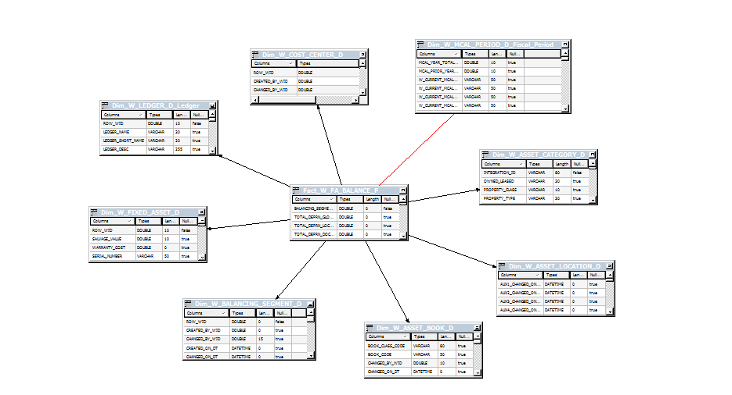

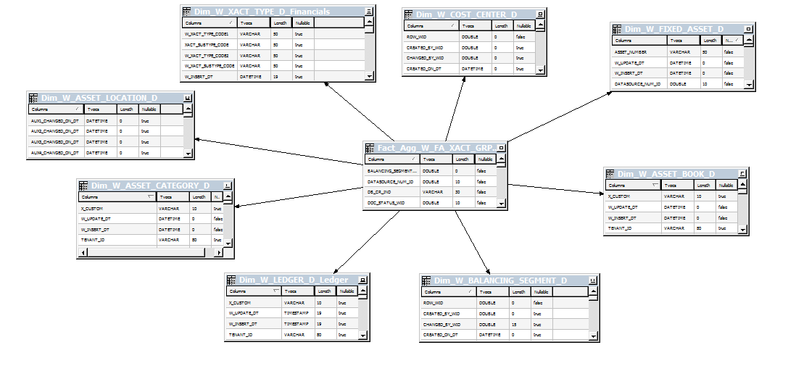

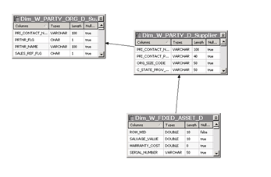

## Database Objects

* + 1. **Tables/Views**

|  |  |  |
| --- | --- | --- |
| RPD Object Name | WH Object Name | Description |
| Dim_W_MCAL_DAY_D_Fiscal_Day | W_MCAL_DAY_D | OOTB Day Dimension |
| Dim_W_MCAL_PERIOD_D_Fiscal_Period | W_MCAL_PERIOD_D | OOTB Period Dimension |
| Dim_W_FIXED_ASSET_D | W_FIXED_ASSET_D | OOTB Fixed Assets Dimension |
| Dim_ W_FIXED_ASSET_D _Ledger | W_FIXED_ASSET_D | OOTB Fixed Assets Dimension |
| Dim_W_COST_CENTER_D | W_COST_CENTER_D | OOTB Cost Center Dimension |
| Dim_W_BALANCING_SEGMENT_D | W_BALANCING_SEGMENT_D | OOTB Balancing Segment Dimension |
| W_GL_SEGMENT_D_TL | SEGMENT_VAL_NAME | OOTB GL Segment Dim |
| W_GL_SEGMENT_D_TL | Segment_Name | OOTB GL Segment Dim |
| Dim_W_NATURAL_ACCOUNT_D | W_NATURAL_ACCOUNT_D | OOTB Natural Account Dim |
| Dim_W_ASSET_BOOK_D | DATASOURCE_NUM_ID | OOTB Asset Book Dim |
| Dim_W_ASSET_BOOK_D | W_ASSET_BOOK_D | OOTB Asset Book Dim |
| Dim_W_ASSET_CATEGORY_D | W_ASSET_CATEGORY_D | OOTB Asset Category Dim |
| Dim_W_ASSET_LOCATION_D | W_ASSET_LOCATION_D | OOTB Asset Location Dim |
| Fact_W_FA_BALANCE_F | W_FA_BALANCE_F | OOTB Fixed Asset Balance Fact |
| Fact_Agg_W_FA_XACT_GRPACCT_FSCLPRD_A | W_FA_XACT_GRPACCT_FSCLPRD_A | OOTB Fixed Asset Fiscal Period Fact |
| Dim_W_FIXED_ASSET_D | X_PO_NUMBER | OOTB Fixed Asset Dimension |
| Dim_W_FIXED_ASSET_D | X_SUPPLIER_WID | OOTB Fixed Asset Dimension |

* + 1. **Data Validations**

N/A

## BMM Layer

### Logical Diagram

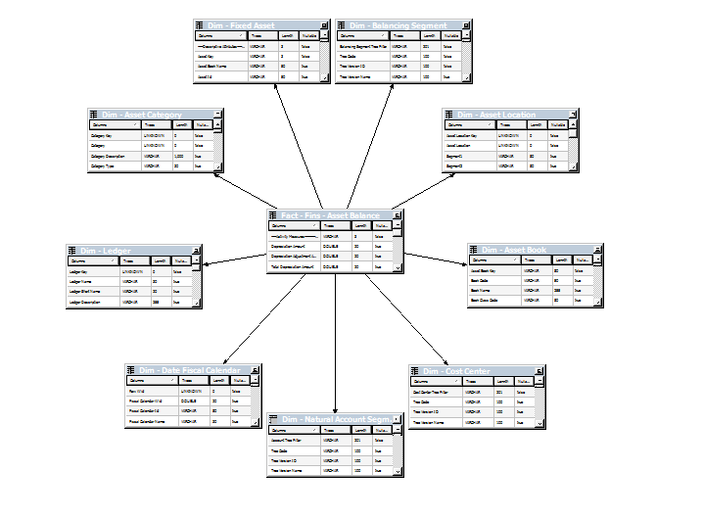

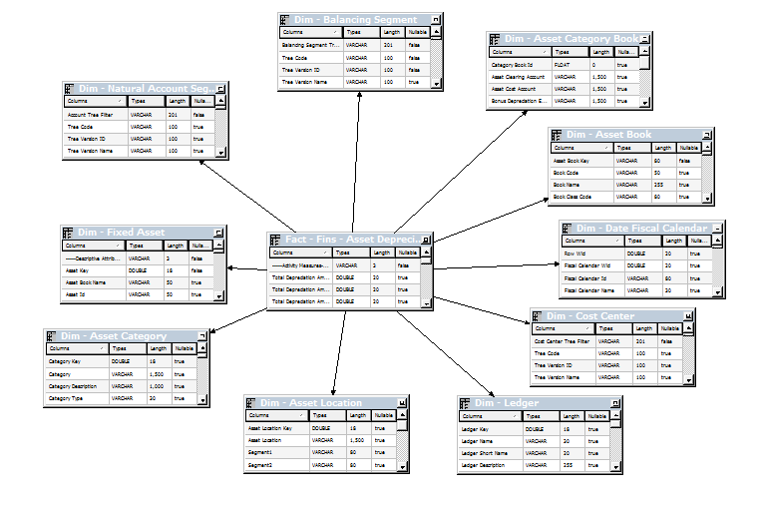

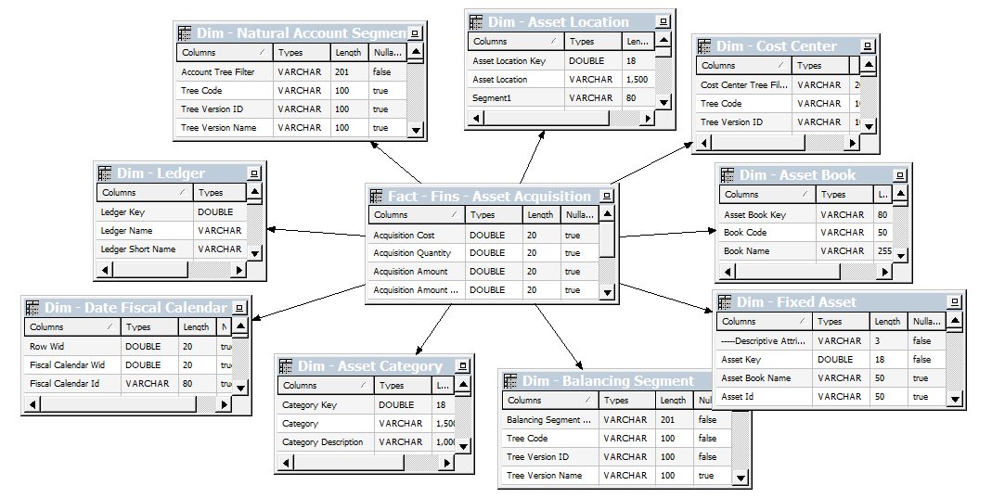

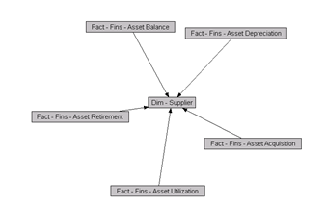

* + 1. **Joins**

|  |  |  |
| --- | --- | --- |
| **Object1.Column** | **Object2.Column** | **Description** |
| Dim_WC_GL_SEGMENT1_DH.X_CHILD_CODE | Dim_W_BALANCING_SEGMENT_D.BALANCING_SEGMENT_VAL_CODE | N/A |
| Dim_WC_GL_SEGMENT1_DH.GL_SEGMENT_WID | Dim_W_GL_SEGMENT_D_Segment1_GLAccount.SCD1_WID | N/A |
| Dim_WC_GL_SEGMENT1_DH.GL_SEGMENT_WID | Dim_W_GL_SEGMENT_D_Segment1.SCD1_WID | N/A |
| Dim_WC_GL_SEGMENT3_DH.X_CHILD_CODE | Dim_W_NATURAL_ACCOUNT_D.NATURAL_ACCOUNT_VAL_CODE | N/A |
| Dim_WC_GL_SEGMENT3_DH.GL_SEGMENT_WID | Dim_W_GL_SEGMENT_D_Segment3_GLAccount.SCD1_WID | N/A |
| Dim_WC_GL_SEGMENT3_DH.GL_SEGMENT_WID | Dim_W_GL_SEGMENT_D_Segment3.SCD1_WID | N/A |
| Dim_WC_GL_SEGMENT5_DH.GL_SEGMENT_WID | Dim_W_GL_SEGMENT_D_Segment5_GLAccount.SCD1_WID | N/A |
| Dim_WC_GL_SEGMENT5_DH.X_CHILD_CODE | Dim_W_COST_CENTER_D.COST_CENTER_VAL_CODE | N/A |
| Dim_WC_GL_SEGMENT5_DH.GL_SEGMENT_WID | Dim_W_GL_SEGMENT_D_Segment5.SCD1_WID | N/A |

* + 1. **Business Rules**

New Logical Column created

|  |  |  |
| --- | --- | --- |
| **Logical Table** | **Logical Column** | **Expression** |
| "Core"."Dim - GL Segment3 Prime" | Account Classification | CASE WHEN ( "Core"."Dim - GL Segment3 Prime"."Segment Code" Like ('1%') OR "Core"."Dim - GL Segment3 Prime"."Segment Code" Like ('2%') OR "Core"."Dim - GL Segment3 Prime"."Segment Code" Like ('3%')) THEN 'Balance Sheet' WHEN ( "Core"."Dim - GL Segment3 Prime"."Segment Code" Like ('4%') OR "Core"."Dim - GL Segment3 Prime"."Segment Code" Like ('5%') OR "Core"."Dim - GL Segment3 Prime"."Segment Code" Like ('6%') OR "Core"."Dim - GL Segment3 Prime"."Segment Code" Like ('7%') OR "Core"."Dim - GL Segment3 Prime"."Segment Code" Like ('8%') OR "Core"."Dim - GL Segment3 Prime"."Segment Code" Like ('9%')) THEN 'Profit and Loss' ELSE 'Unknown' END |
| Fact - Fins - Asset Acquisition | Acquisition Quantity | CASE WHEN ("Oracle Data Warehouse"."Catalog"."dbo"."Dim_W_XACT_TYPE_D_Financials"."W_XACT_SUBTYPE_CODE" IN ('ADDITION COST','CIP ADDITION COST') AND "Oracle Data Warehouse"."Catalog"."dbo"."Dim_W_XACT_TYPE_D_Financials"."W_XACT_TYPE_CODE" IN ('ADDITION', 'CIP ADDITION'))  THEN  "Oracle Data Warehouse"."Catalog"."dbo"."Fact_W_FA_XACT_F"."XACT_UNITS"  WHEN "Oracle Data Warehouse"."Catalog"."dbo"."Dim_W_XACT_TYPE_D_Financials"."W_XACT_TYPE_CODE" IN ('ADJUSTMENT', 'CIP ADJUSTMENT')  THEN  "Oracle Data Warehouse"."Catalog"."dbo"."Fact_W_FA_XACT_F"."XACT_UNITS"  WHEN ("Oracle Data Warehouse"."Catalog"."dbo"."Dim_W_XACT_TYPE_D_Financials"."W_XACT_SUBTYPE_CODE" in ('DEPRECIATION AMOUNT','DEPRECIATION ADJUSTMENT') AND "Oracle Data Warehouse"."Catalog"."dbo"."Dim_W_XACT_TYPE_D_Financials"."W_XACT_TYPE_CODE" = 'DEPRECIATION')  THEN  "Oracle Data Warehouse"."Catalog"."dbo"."Fact_W_FA_XACT_F"."XACT_UNITS"  WHEN ("Oracle Data Warehouse"."Catalog"."dbo"."Dim_W_XACT_TYPE_D_Financials"."W_XACT_SUBTYPE_CODE" IN('RETIREMENT COST', 'CIP RETIREMENT COST') AND "Oracle Data Warehouse"."Catalog"."dbo"."Dim_W_XACT_TYPE_D_Financials"."W_XACT_TYPE_CODE" IN ('RETIREMENT','CIP RETIREMENT'))  THEN  ((-1)*("Oracle Data Warehouse"."Catalog"."dbo"."Fact_W_FA_XACT_F"."XACT_UNITS" ))  ELSE 0  END |
| Dim_W_FIXED_ASSET_D | Purchase Order Number | "Oracle Data Warehouse"."Catalog"."dbo"."Dim_W_FIXED_ASSET_D"."X_PO_NUMBER" |
| Dim_W_FIXED_ASSET_D | Supplier Number | CASE WHEN "Core"."Dim - Supplier"."Supplier Name"='Unspecified' THEN NULL ELSE "Core"."Dim - Supplier"."Supplier Number" END |
| Dim_W_FIXED_ASSET_D | Supplier Name | CASE WHEN "Core"."Dim - Supplier"."Supplier Name"='Unspecified' THEN NULL ELSE "Core"."Dim - Supplier"."Supplier Name" END |

## Presentation Layer

|  |  |  |
| --- | --- | --- |
| **Subject Area** | **Presentation Table** | **Presentation Column** |
| Financials - Asset Overview | Time | Fiscal Period |
| Financials - Asset Overview | Asset | Asset Number |
| Financials - Asset Overview | Asset | Date Placed in Service |
| Financials - Asset Overview | Asset | Serial Number |
| Financials - Asset Overview | Asset | Tag Number |
| Financials - Asset Overview | Asset | Description |
| Financials - Asset Overview | Asset | Original Cost |
| Financials - Asset Overview | Ledger | Ledger Name |
| Financials - Asset Overview | Cost Center | Cost Center Number |
| Financials - Asset Overview | Balancing Segment | Balancing Segment Name |
| Financials - Asset Overview | Natural Account | Account Name |
| Financials - Asset Overview | Asset Book | Book Code |
| Financials - Asset Overview | Asset Book | Book Class Name |
| Financials - Asset Overview | Asset Category | Major Category |
| Financials - Asset Overview | Asset Category | Minor Category |
| Financials - Asset Overview | Asset Location | Asset Location Name |
| Financials - Asset Overview | Prime | Account Classification |
| Financials - Asset Overview | Facts - Asset Balance | Current Cost |
| Financials - Asset Overview | Facts - Asset Balance | Total Depreciation Amount |
| Financials - Asset Overview | Facts - Asset Balance | Fiscal YTD Depreciation Amount |
| Financials - Asset Overview | Facts - Asset Balance | Accumulated Depreciation Amount |
| Financials - Asset Overview | Facts - Asset Balance | Net Book Value |
| Financials - Asset Overview | Facts - Asset Acquisition | Acquisition Quantity |
| Financials - Asset Overview | Asset | PO Number |
| Financials - Asset Overview | Asset | Supplier Name |
| Financials - Asset Overview | Asset | Supplier Number |

# Report Design

## Report Details

|  |  |  |  |  |  |
| --- | --- | --- | --- | --- | --- |
| **Report Name** | **Report Location** | **Subject Area** | **Dashboard** | **Dashboard Page** | **Description** |
| Cigna Fixed Asset Reporting | /Shared Folders/ | Financials - Asset Overview | Cigna Fixed Asset | Cigna Fixed Asset | This Report contains the Cigna Fixed Asset Report |
| For project level standards in reports and prompts please refer Technical Design Document (**DS-140_BI-OOB-0004_TS_OOB_CORE_CHANGES**). | | | | | |

## User Prompts

|  |  |  |  |  |  |
| --- | --- | --- | --- | --- | --- |
| **Dashboard Prompt Name** | **Prompt Label** | **Prompt Expression** | **Prompt Type** | **Default To** | **Set Variable** |
| Ledger Name | Ledger Name | Is equal to/is In | Dashboard | CIGNA_GAAP_ENTERPRISE | Yes |
| Period | Accounting Period | Is equal to/is In | Dashboard | CIGNA_CURRENT_PERIOD | Yes |
| Asset Book Name | Asset Book Name | Is equal to/is In | Dashboard | CIGNA_FINANCIAL | Yes |
| Company | Company | Is equal to/is In | Dashboard | N/A | N/A |
| Expense Center Parent | Expense Center Parent | Is equal to/is In | Dashboard | N/A | N/A |
| Prime Parent | Prime Parent | Is equal to/is In | Dashboard | N/A | N/A |
| Asset Major Category | Asset Major Category | Is equal to/is In | Dashboard | N/A | N/A |
| Expense Center | Expense Center | Is equal to/is In | Dashboard | N/A | N/A |
| Prime | Prime | Is equal to/is In | Dashboard | N/A | N/A |
| Asset Number | Asset Number | Is equal to/is In | Dashboard | N/A | N/A |
| Asset Classification | Asset Classification | Is equal to/is in | Dashboard | ‘Profit and Loss’ | N/A |
| Asset Minor Category | Asset Minor Category | Is equal to/is In | Dashboard | N/A | N/A |
| PO Number | PO Number | Is equal to/is in | Dashboard | N/A | N/A |
| Supplier Name | Supplier Name | Is equal to/is in | Dashboard | N/A | N/A |
| Supplier Number | Supplier Number | Is equal to/is in | Dashboard | N/A | N/A |
| Location Code | Location Code | Is equal to/is in | Dashboard | N/A | N/A |

## Header

|  |  |
| --- | --- |
| **Report Name** | **Report Location** |
| Cigna Fixed Asset | /shared/Cigna Custom Financials/Cigna Fixed Asset/Reports |

## Data Fields

|  |  |  |  |  |  |
| --- | --- | --- | --- | --- | --- |
| **Column Name** | **Column Description** | **Calculated?** | **BMM Expression** | **Variable Name** | **Comment** |
| Period Name | Period | No | "Oracle Data Warehouse"."Catalog"."dbo"."Dim_W_MCAL_DAY_D_Fiscal_Day"."MCAL_PERIOD_NAME" | N/A | N/A |
| Asset Book Name | Asset Book Name | No | "Oracle Data Warehouse"."Catalog"."dbo"."Dim_W_ASSET_BOOK_D"."BOOK_CODE" | N/A | N/A |
| Ledger Name | Ledger Name | No | "Oracle Data Warehouse"."Catalog"."dbo"."Dim_W_LEDGER_D_Ledger"."LEDGER_NAME" | N/A | N/A |
| Asset Number | Asset Number | No | "Oracle Data Warehouse"."Catalog"."dbo"."Dim_W_FIXED_ASSET_D"."ASSET_NUMBER" | N/A | N/A |
| PO Number | PO Number | No | "Oracle Data Warehouse"."Catalog"."dbo"."Dim_W_FIXED_ASSET_D"."PO Number" | N/A | N/A |
| Supplier Name | Supplier Name | No | CASE WHEN "Core"."Dim - Supplier"."Supplier Name"='Unspecified' THEN NULL ELSE "Core"."Dim - Supplier"."Supplier Name" END | N/A | N/A |
| Supplier Number | Supplier Number | No | CASE WHEN “Core”.”Dim – Supplier”.”Supplier Number”=’Unspecified’ THEN NULL ELSE “Core”.”Dim – Supplier”.”Supplier Number” END | N/A | N/A |
| Date Placed in Service | Date Place in Service | No | “Oracle Data Warehouse”.”Catalog”.”dbo”.”Dim_W_FIXED_ASSET_D”.”DATE_PLACED_IN_SERVICE” | N/A | N/A |
| Tag Number | Tag Number | No | “Oracle Data Warehouse”.”Catalog”.”dbo”.”Dim_W_FIXED_ASSET_D”.”TAG_NUMBER” | N/A | N/A |
| Lease Number | Lease Number | No | “Oracle Data Warehouse”.”Catalog”.”dbo”.”Dim_W_FIXED_ASSET_D”.”LEASE_CODE” | N/A | N/A |
| Serial Number | Serial Number | No | “Oracle Data Warehouse”.”Catalog”.”dbo”.”Dim_W_FIXED_ASSET_D”.”SERIAL_NUMBER” | N/A | N/A |
| Description | Description | No | “Oracle Data Warehouse”.”Catalog”.”dbo”.”Dim_W_FIXED_ASSET_D_TL”.”ASSET_DESCR” | N/A | N/A |
| Cost | Cost | No | INDEXCOL( CASE VALUEOF(NQ_SESSION.”PREFERRED_CURRENCY”) WHEN ‘Local Currency’ THEN 0 WHEN ‘Document Currency’ THEN 1 WHEN ‘Global Currency 1’ THEN 2 WHEN ‘Global Currency 2’ THEN 3 WHEN ‘Global Currency 3’ THEN 4 ELSE 5 END , “Oracle Data Warehouse”.”Catalog”.”dbo”.”Fact_W_FA_BALANCE_F”.”CURRENT_COST_LOC_AMT”, “Oracle Data Warehouse”.”Catalog”.”dbo”.”Fact_W_FA_BALANCE_F”.”CURRENT_COST_DOC_AMT”, “Oracle Data Warehouse”.”Catalog”.”dbo”.”Fact_W_FA_BALANCE_F”.”CURRENT_COST_GLOBAL1_AMT”, “Oracle Data Warehouse”.”Catalog”.”dbo”.”Fact_W_FA_BALANCE_F”.”CURRENT_COST_GLOBAL2_AMT”, “Oracle Data Warehouse”.”Catalog”.”dbo”.”Fact_W_FA_BALANCE_F”.”CURRENT_COST_GLOBAL3_AMT”, CAST ( NULL AS DOUBLE PRECISION ))””””””””” | N/A | N/A |
| Depreciation Start Date | Depreciation Start Date | No | “Oracle Data Warehouse”.”Catalog”.”dbo”.”Dim_W_FIXED_ASSET_D”.”DEPRECIATION_START_DATE” | N/A | N/A |
| Remaining Life | Remaining Life In Months | No | CASE WHEN “Oracle Data Warehouse”.”Catalog”.”dbo”.”Dim_W_FIXED_ASSET_D”.”TOTAL_LIFE_IN_MONTHS” - (TimeStampDiff(SQL_TSI_MONTH , “Oracle Data Warehouse”.”Catalog”.”dbo”.”Dim_W_FIXED_ASSET_D”.”DATE_PLACED_IN_SERVICE”, current_date )) <0 THEN 0  ELSE  “Oracle Data Warehouse”.”Catalog”.”dbo”.”Dim_W_FIXED_ASSET_D”.”TOTAL_LIFE_IN_MONTHS” - (TimeStampDiff(SQL_TSI_MONTH, “Oracle Data Warehouse”.”Catalog”.”dbo”.”Dim_W_FIXED_ASSET_D”.”DATE_PLACED_IN_SERVICE”, current_date ))  END | N/A | N/A |
| Asset Major Category | Asset Major Category | No | “Oracle Data Warehouse”.”Catalog”.”dbo”.”Dim_W_ASSET_CATEGORY_D”.”MAJOR_CATEGORY” | N/A | N/A |
| Asset Minor Category | Asset Minor Category | No | “Oracle Data Warehouse”.”Catalog”.”dbo”.”Dim_W_ASSET_CATEGORY_D”.”MINOR_CATEGORY” | N/A | N/A |
| Input Ledger Co | Balance Segment Name | No | LOOKUP( DENSE “Oracle Data Warehouse”.”Catalog”.”dbo”.”Lookup – Domain GL Segment Values”.”Segment_Name”, “Oracle Data Warehouse”.”Catalog”.”dbo”.”Dim_W_BALANCING_SEGMENT_D”.”INTEGRATION_ID”, VALUEOF(NQ_SESSION.”USER_LANGUAGE_CODE”), “Oracle Data Warehouse”.”Catalog”.”dbo”.”Dim_W_BALANCING_SEGMENT_D”.”DATASOURCE_NUM_ID”) | N/A | N/A |
| Expense Center | Cost Center Number | No | “Oracle Data Warehouse”.”Catalog”.”dbo”.”Dim_W_COST_CENTER_D”.”COST_CENTER_VAL_CODE” | N/A | N/A |
| Cost Pool | Cost Pool | No | CASE WHEN “Core”.”Dim – Prealloc Cost Pool”.”Cost Pool Code” =’__NOT_APPLICABLE__’ THEN NULL ELSE “Core”.”Dim – Prealloc Cost Pool”.”Cost Pool Code” END | N/A | N/A |
| Asset Location | Asset Location | No | “Oracle Data Warehouse”.”Catalog”.”dbo”.”Dim_W_ASSET_LOCATION_D”.”CONCATENATED_SEGMENT_VALUE” | N/A | N/A |
| Units | Units | No | case  when  ( "Oracle Data Warehouse"."Catalog"."dbo"."Fact_W_FA_BALANCE_F"."INEFFECTIVE_DT_WID" = 0  OR "Oracle Data Warehouse"."Catalog"."dbo"."Fact_W_FA_BALANCE_F"."INEFFECTIVE_DT_WID" > "Oracle Data Warehouse"."Catalog"."dbo"."Fact_W_FA_BALANCE_F"."BALANCE_DT_WID"  OR "Oracle Data Warehouse"."Catalog"."dbo"."Fact_W_FA_BALANCE_F"."INEFFECTIVE_DT_WID" is null )  then "Oracle Data Warehouse"."Catalog"."dbo"."Fact_W_FA_BALANCE_F"."X_UNITS"  when ( "Oracle Data Warehouse"."Catalog"."dbo"."Fact_W_FA_BALANCE_F"."INEFFECTIVE_DT_WID" = "Oracle Data Warehouse"."Catalog"."dbo"."Fact_W_FA_BALANCE_F"."BALANCE_DT_WID"  AND "Oracle Data Warehouse"."Catalog"."dbo"."Fact_W_FA_BALANCE_F"."X_CUSTOM" = 'NEW' )  THEN "Oracle Data Warehouse"."Catalog"."dbo"."Fact_W_FA_BALANCE_F"."X_UNITS"  else 0  end | N/A | N/A |
| Period Depreciation | Period Depreciation | No | CASE WHEN TODATE(“Core”.”Fact – Fins – Asset Depreciation”.”Total Depreciation Amount” , “Core”.”Date – Fiscal Calendar”.”Fiscal Period”) IS NULL THEN 0 ELSE TODATE(“Core”.”Fact – Fins – Asset Depreciation”.”Total Depreciation Amount” , “Core”.”Date – Fiscal Calendar”.”Fiscal Period”) END | N/A | N/A |
| YTD Depreciation | YTD Depreciation | No | CASE WHEN TODATE(“Core”.”Fact – Fins – Asset Depreciation”.”Total Depreciation Amount” , “Core”.”Date – Fiscal Calendar”.”Fiscal Year”) IS NULL THEN 0 ELSE TODATE(“Core”.”Fact – Fins – Asset Depreciation”.”Total Depreciation Amount” , “Core”.”Date – Fiscal Calendar”.”Fiscal Year”) END | N/A | N/A |
| LTD Depreciation | LTD Depreciation | No | INDEXCOL( CASE VALUEOF(NQ_SESSION.”PREFERRED_CURRENCY”) WHEN ‘Local Currency’ THEN 0 WHEN ‘Document Currency’ THEN 1 WHEN ‘Global Currency 1’ THEN 2 WHEN ‘Global Currency 2’ THEN 3 WHEN ‘Global Currency 3’ THEN 4 ELSE 5 END , “Oracle Data Warehouse”.”Catalog”.”dbo”.”Fact_W_FA_BALANCE_F”.”ACC_DEPRN_LOC_AMT”, “Oracle Data Warehouse”.”Catalog”.”dbo”.”Fact_W_FA_BALANCE_F”.”ACC_DEPRN_DOC_AMT”, “Oracle Data Warehouse”.”Catalog”.”dbo”.”Fact_W_FA_BALANCE_F”.”ACC_DEPRN_GLOBAL1_AMT”, “Oracle Data Warehouse”.”Catalog”.”dbo”.”Fact_W_FA_BALANCE_F”.”ACC_DEPRN_GLOBAL2_AMT”, “Oracle Data Warehouse”.”Catalog”.”dbo”.”Fact_W_FA_BALANCE_F”.”ACC_DEPRN_GLOBAL3_AMT”, CAST ( NULL AS DOUBLE PRECISION )) | N/A | N/A |
| NBV | Net Book Value | No | “Core”.”Fact – Fins – Asset Balance”.”Current Cost” – “Core”.”Fact – Fins – Asset Balance”.”Accumulated Depreciation Amount” | N/A | N/A |
| Depreciation Method | Depreciation Method | No | Dim_W_FIXED_ASSET_D.X_DEPRN_METHOD_CODE | N/A | N/A |

## Report Filters

|  |  |
| --- | --- |
| **Column Name** | **Filter Condition** |
| Ledger Name | CIGNA_GAAP_ENTERPRISE |
| Fiscal Period | CIGNA_CURRENT_PERIOD |
| Book Code | CIGNA_FINANCIAL |
| Prime Parent | Is Prompted |
| Account Code | Is Prompted |
| Cost Center Number | Is Prompted |
| Asset Number | Is Prompted |
| Expense Center Parent | Is Prompted |
| Major Category | Is Prompted |
| Minor Category | Is Prompted |
| PO Number | Is Prompted |
| Supplier Name | Is Prompted |
| Supplier Number | Is Prompted |
| Company | Is Prompted |
| Account Classification | Is Prompted |
| Location Code | Is Prompted |

## Interfaces- External

N/A

## Security

|  |  |
| --- | --- |
| **Group** | **Application Roles** |
| Financial Analyst | Financial Analyst |
| Fixed Asset Accounting Manager EBS | Fixed Asset Accounting Manager EBS |

# Performance

## Performance Considerations/Requirements

These roles Financial Analyst & Fixed Asset Accounting Manager EBS roles are set to time out any request after running for twenty minutes.

## Stress Test

N/A

## Loading Timing/Benchmarking

N/A

# Open and Closed Issues

1. Add open issues that you identify while writing or reviewing this document to the open issues section. As you resolve issues, move them to the closed issues section and keep the issue ID the same. Include an explanation of the resolution.  
     
   When this work product is complete, any open issues should be transferred to the project- or process-level Issue Log (Manage focus area) and managed using a project level Issue Form (Manage focus area). In addition, the open items should remain in the open issues section of this work product, but flagged in the resolution column as being transferred.

## Open Issues

| **ID** | **Issue** | **Resolution** | **Responsibility** | **Target Date** | **Impact Date** |
| --- | --- | --- | --- | --- | --- |
| 1 | Voucher column | Need to map this column |  |  |  |

## Closed Issues

N/A

| **ID** | **Issue** | **Resolution** | **Responsibility** | **Target Date** | **Impact Date** |
| --- | --- | --- | --- | --- | --- |
| 1. | Cost Pool column | Mapped from new created Cost Pool column in the subject area | Dev Team | Release 1B Go Live |  |
| 2. | Depreciation Method Column | Mapped from new created Depreciation Method column in the subject area | Dev Team | Release 1B Go Live |  |
| 3. | SR 3-11522809745  BI Apps- ODI mapping pulling extra records with an expense center for Fixed Assets area. | Added prompt to segregate records based on Asset Classification | Dev Team | Release 1B Go Live |  |